PYTHON
Python is a general-purpose interpreted, interactive, object-oriented, and high-level programming language. An interpreted language, Python has a design philosophy that emphasizes code readability (notably using whitespace indentation to delimit code blocks rather than curly brackets or keywords), and a syntax that allows programmers to express concepts in fewer lines of code than might be used in languages such as C++or Java. It provides constructs that enable clear programming on both small and large scales. Python interpreters are available for many operating systems. CPython, the reference implementation of Python, is open source software and has a community-based development model, as do nearly all of its variant implementations. CPython is managed by the non-profit Python Software Foundation. Python features a dynamic type system and automatic memory management. It supports multiple programming paradigms, including object-oriented, imperative, functional and procedural, and has a large and comprehensive standard library
DJANGO
Django is a high-level Python Web framework that encourages rapid development and clean, pragmatic design. Built by experienced developers, it takes care of much of the hassle of Web development, so you can focus on writing your app without needing to reinvent the wheel. It’s free and open source.
Django's primary goal is to ease the creation of complex, database-driven websites. Django emphasizes reusabilityand "pluggability" of components, rapid development, and the principle of don't repeat yourself. Python is used throughout, even for settings files and data models.
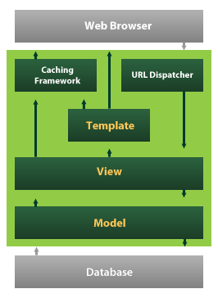
Django also provides an optional administrative create, read, update and delete interface that is generated dynamically through introspection and configured via admin models

